|  |  |  |
| --- | --- | --- |
| Safeguard Send Core and Safeguard Send Core Plus | | |
|  |  |  |
| An Outlook Add-In by Sperry Software | | |

# Customization Request Form

Safeguard Send Core is also a Microsoft 365 based Outlook add-in similar to Safeguard Send for Microsoft 365 (our flagship product) in that it also helps users to prevent critical email mistakes when sending emails by displaying a warning prompt. In fact, this add-in duplicates the functionality but with a reduced feature set, along with a reduced price. It's a lightweight, low-cost tool to prevent mistakes when going to send emails.

The general idea is that this product can be customized with your exact rules. When you do so, the Safeguard Send Core product instantly becomes the Safeguard Send Core Plus product.

You provide your desired set of rules and conditions, then we create your customized version. Because of this, we need only host the actual add-in and provide ongoing maintenance and updates to newer versions.

All our examples show emails being sent out of our default domain, sperrysoftware.com. The example external email addresses all end in either gmail.com or outlook.com (as in this case).

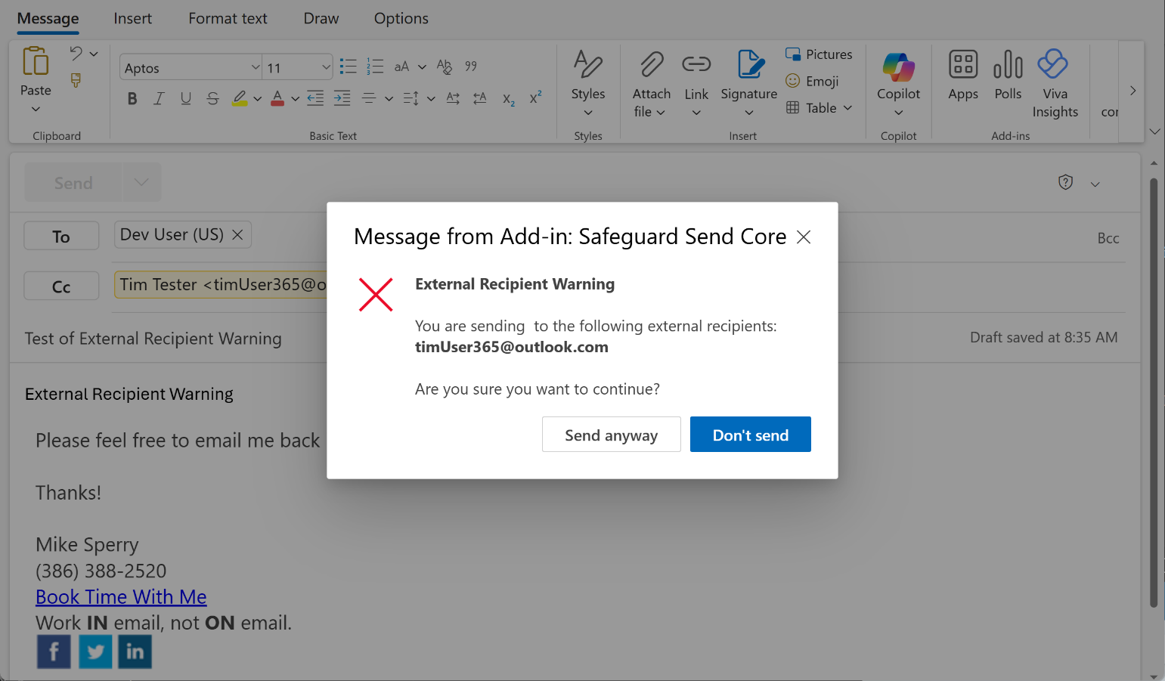

You’ll notice that there a bold font is used for some elements. This is a design choice by us and is the default for most prompts. However, some limited HTML formatting is available. See this [Microsoft article to specify markdown for italics, bulleted lists, numbered lists and URL links](https://learn.microsoft.com/en-us/office/dev/add-ins/outlook/onmessagesend-onappointmentsend-events?tabs=windows#limitations-to-formatting-the-dialog-message-using-markdown). You can add these special markdown elements if you would like, just add them inline as you specify your text prompts.

However, sometimes a prompt without the HTML formatting is shown:

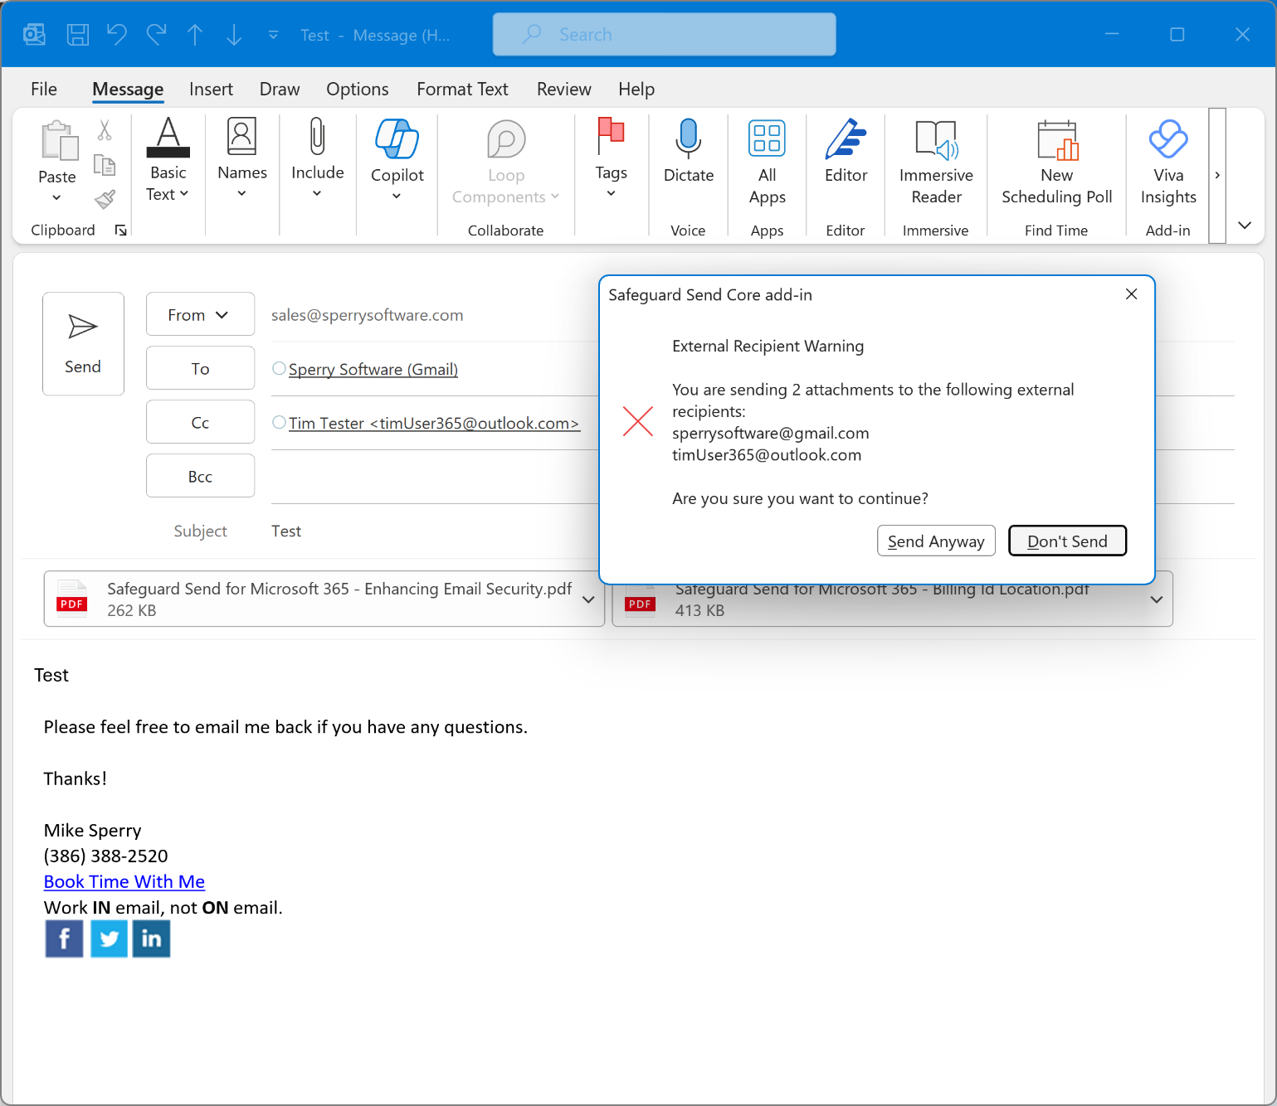

Which version that gets displayed (plain or HTML formatted) is a function of which version of Outlook you are using. If you are using traditional desktop Outlook for Windows, you will see the plain text version of the prompt. If you are using new Outlook for Windows, Outlook on the Web, or Outlook for Mac, you will see the HTML formatted prompt. Because new Outlook for Windows and Outlook on the Web is the future for Microsoft, we will show the HTML formatted version of the prompts unless it’s necessary for you to see the plain text version.

With that in mind, start by detailing which rules should be on or off and if the rule is on, what the text should be along with any other notes for the developer.

# Rule: Warn when sending an email with external recipients

When this rule is enabled (which is the default) a warning prompt appears when sending an email outside your domain(s).



**Enabled/Disabled:**

Add any additional company domains:

The default is to warn show **only** the external email addresses. Do you want **all** recipients shown (yes/no):

The default text is “You are sending N attachments to the following external recipients:” – Is the default text acceptable? If not specify the text you would like to see:

Add any other comments to the developer:

# Rule: Warn when sending an email with more than N recipients

When this rule is on (which is disabled by default) a warning prompt appears when sending an email with more than say, 3 recipients:

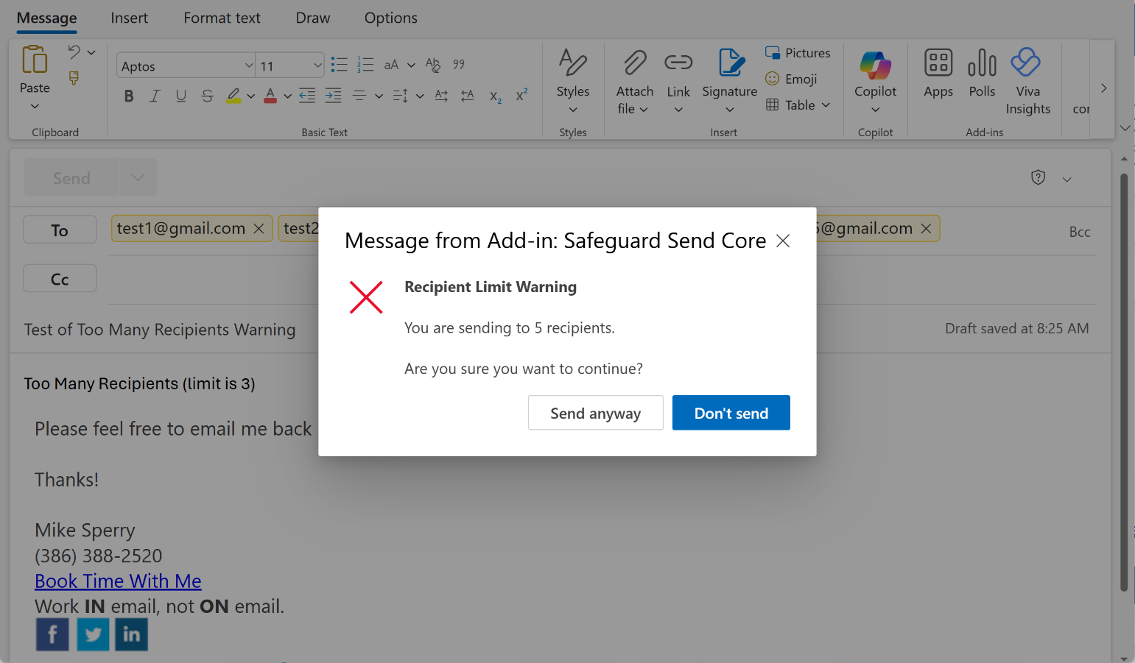

**Enabled/Disabled:**

If enabled, how many recipients should cause the prompt to appear?

The default text is “You are sending to N recipients:” – is the default text acceptable? If not, specify it here:

N will be replaced by the actual number of recipients, and it counts both external and internal recipients.

Add any other comments to the developer:

# Rule: Warn when sending an email with more than N attachments

When this rule is enabled (which is disabled by default) a warning prompt appears when sending an email with more than N attachments:

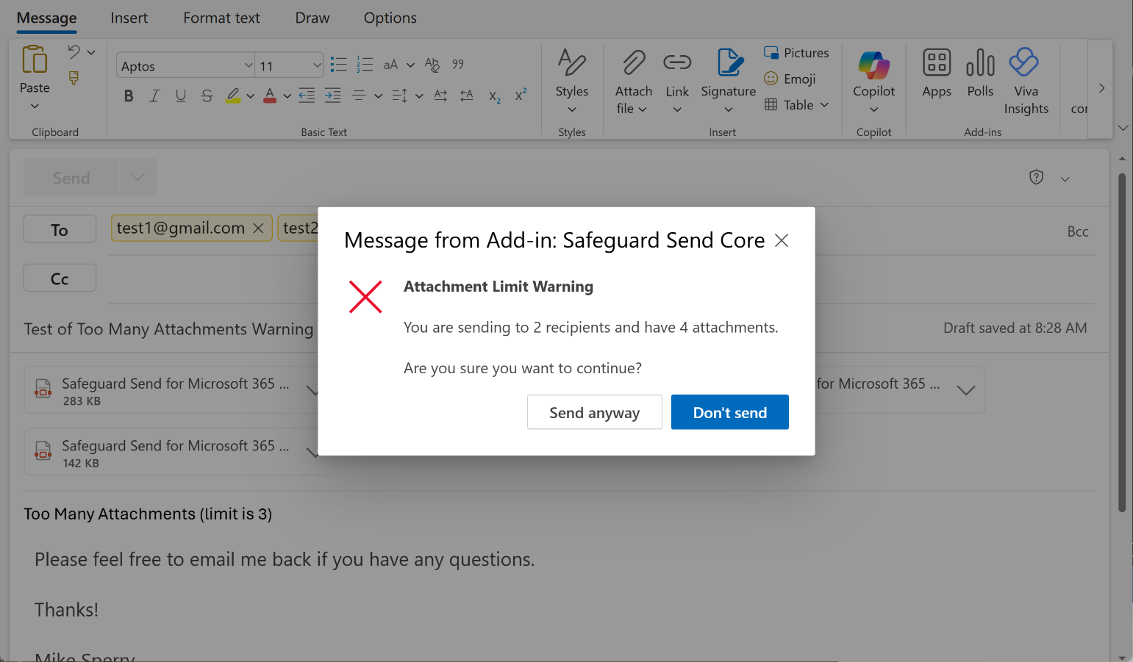

**Enabled/Disabled:**

If enabled, how many attachments should cause the warning prompt to appear?

The default text is “You are sending to N recipients and have N attachments.” Is the default text acceptable? If not, specify it here (and note that you can choose to ignore the **sending to N recipients** portion, and just display the number of attachments if you prefer):

Add any other comments to the developer:

# Rule: Warn when sending to specific email addresses or domains

When this rule is enabled (which is disabled by default) a warning prompt appears when sending an email to a specific email address or domain:

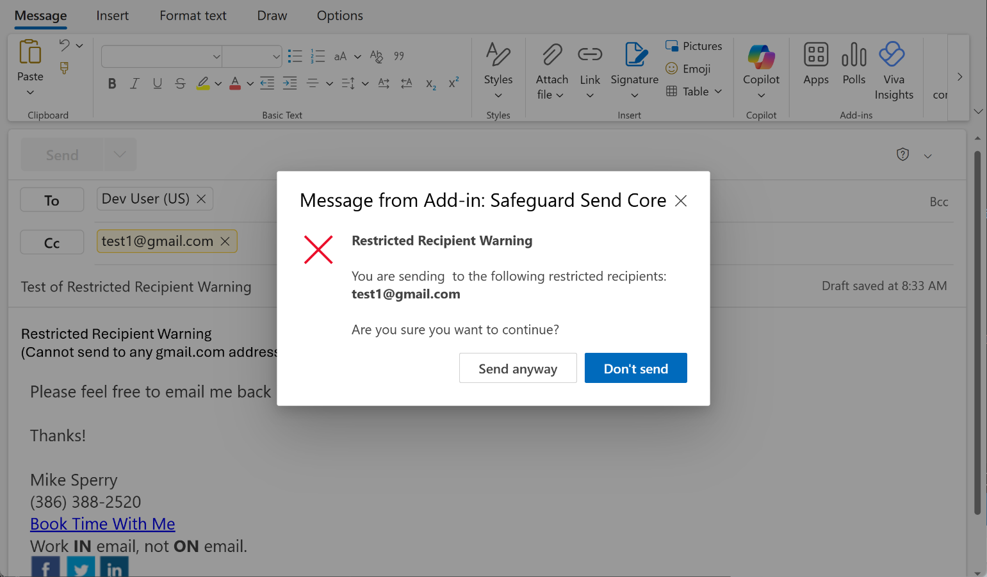

In the above example, the rule is turned on such that a prompt appears anytime a user sends an email to anyone with a Gmail address. You can specify a specific email address (or list of email addresses), and/or you can specify entire domains using a wildcard (e.g., *gmail.com).

**Enabled/Disabled:**

If enabled, please provide the list of restricted emails and/or domains:

What should the default text be:

Add any other comments to the developer:

# Rule: Warn when replying to all

When this rule is enabled (which is disabled by default) a warning prompt appears whenever a user performs a reply to all:

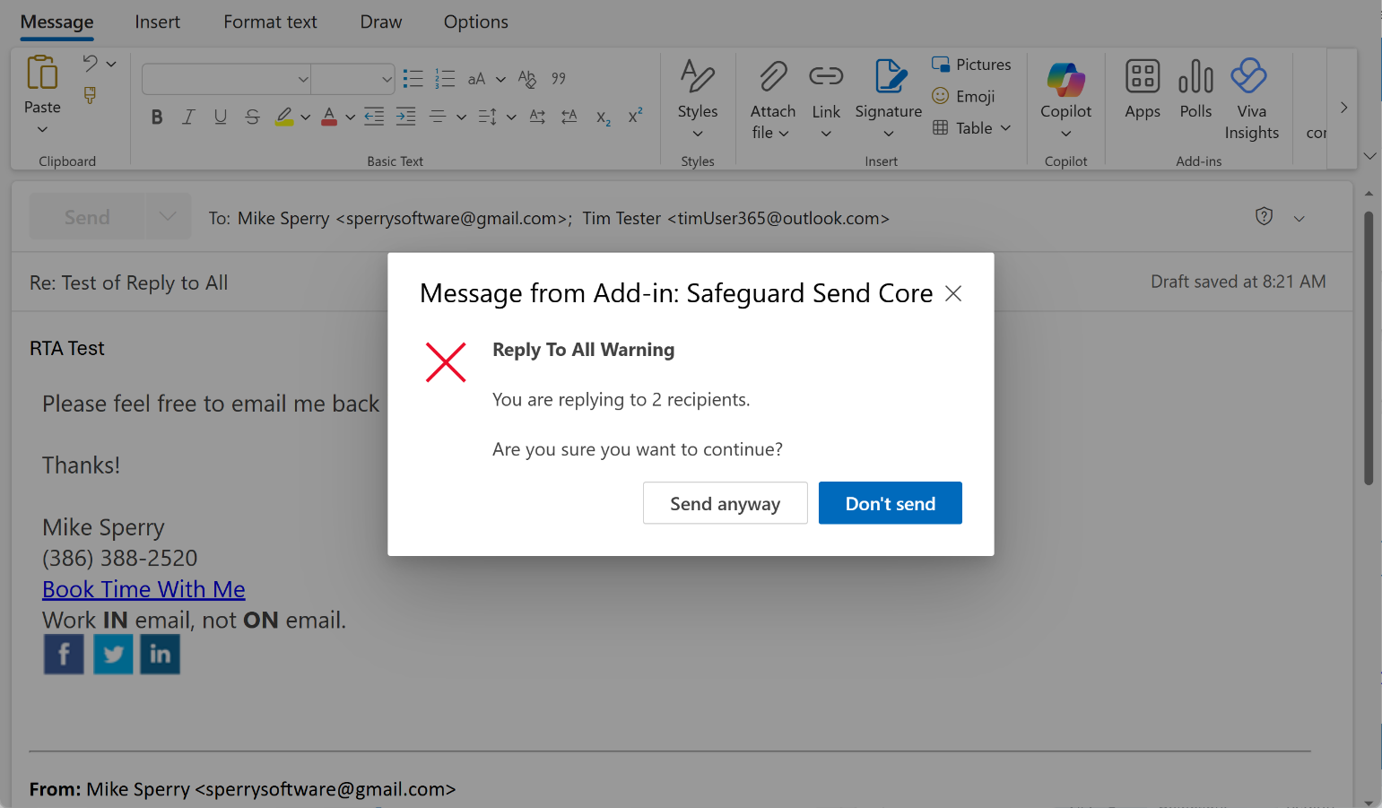

Note that this rule will fire even if the user changes the subject.

**Enabled/Disabled:**

What should the default text be:

Add any other comments to the developer:

# Other options

In our examples above, we used sample emails that violated only one rule at a time for simplicity. However, if you enable more than one rule and more than one rule is violated, a special prompt occurs that is a list of each violated rule’s text:

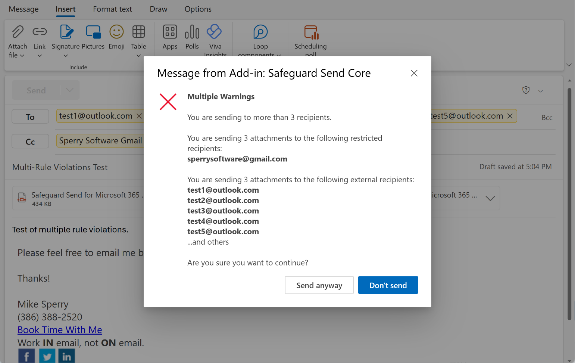

The default title in this case is “Multiple Warnings”. If this is not acceptable, what should the default text be?

Notice also in the sample image that the third rule is trying to display all the (external) recipients, but in the background, you can see that there are in fact 6 external recipients. By default, the words “…and others” will always appear (for any rule that lists recipients) if there are more than 5 external recipients. You can request different text and/or change the number of recipients from five to say, 3. It is not advisable to list more than 5 because the window will run out of space.

Change the number of recipients shown from 5 to N (specify N):

Change “…and others” text to:

Also notice the default text that has appeared in every prompt so far: “Are you sure you want to continue?”. This can also be changed if you prefer:

The “Send Anyway” and “Don’t Send” button text cannot be changed.

# Completion and next steps

Your name:

Your email address:

Please list a 2nd technical contact name:

2nd technical contact email address:

We need the above information in the event that Microsoft deploys a version of Outlook that breaks the normal operation of the add-in. We want to be able to get in touch with everyone quickly. We also use the information to let you know about changes to the add-in.

That’s it! Feel free to add any other comments, questions or concerns that didn’t apply to a particular section here:

When you’re ready, send this completed form to [sales@sperrysoftware.com](mailto:sales@sperrysoftware.com). We will then get started customizing your add-in. This step takes anywhere between 2-3 business days depending on the complexity of the requests above.

After we complete your customization requests, we will email you the URL to a new manifest file that represents your customizations that you can upload directly to Microsoft Admin Center.